ZOMATO RESTAURANTS ANALYSIS

Objective Questions

1. What is the total no. of tables present in the data?

* There are two tables in the data –
* Raw Data
* Country Description

1. What is the total no. of attributes present in the data?

* There are 22 distinct attributes or column headers in the data including both the tables.

1. How many categorical columns are there in the data? [Search about categorical and continuous data, and try to answer this question]

* There are in total 18 categorical column in the data.

1. The data consists of some inconsistent and missing values so ensure that the data used for further analysis is cleaned.

* Yes! There were some missing values in the data. Therefore, the corresponding row is deleted to remove any kind of inconsistency and to get accurate result.

1. Using the LookUp functions, fill up the countries in the original data using the country code.

* DONE

1. Create a table to represent the number of restaurants opened in each country.

* DONE

|  |  |
| --- | --- |
| Australia | 24 |
| Brazil | 60 |
| Canada | 4 |
| India | 8652 |
| Indonesia | 21 |
| New Zealand | 40 |
| Philippines | 22 |
| Qatar | 20 |
| Singapore | 20 |
| South Africa | 60 |
| Sri Lanka | 20 |
| Turkey | 34 |
| United Arab Emirates | 60 |
| United Kingdom | 80 |
| United States of America | 425 |

1. Also the management wants to look at the number of restaurants opened in each year, so provide them with something here.

* The above chart shows the variation in the number of restaurants opened from 2010-2018.

1. What is the total number of restaurants in India which are in the price range 4?

* There are total 388 restaurants in India which are in the price range of 4
* The Countif function is used to get the result –
* =COUNTIFS('Raw Data'!$D$2:$D$9543,"India",'Raw Data'!$Q$2:$Q$9543,"4")

1. What is the average number of voters for the restaurants in each country according to the data?

* The above chart shows the average number of voters for each restaurant in each country.
* It shows that countries like Indonesia, UAE and USA have higher no. of people reviewing the restaurants.

1. Calculate the average rating for all the restaurants which have price_range < 4 and provide online delivery. Use only “IF” function, Logical Operators and Aggregation functions to solve this problem.

Note: Don’t use Conditional aggregation in this question.

* 3.29 is the average rating for all the restaurants which have price_range < 4 and provide online delivery.
* The formula used is
* =AVERAGE(FILTER('Raw Data'!U2:U9543,'Raw Data'!N2:N9543 = "Yes",'Raw Data'!Q2:Q9543 < 4))

1. Using Conditional formatting highlight the rows of restaurants that are located in the countries or cities that you’ve suggested to the management for opening new restaurants.

* The recommended country for opening a restaurant would be Canada, Qatar, Singapore, Sri Lanka, Australia, Indonesia, Philippines and Turkey as they have below average no. of restaurants.

1. Create a new customized price column which consists of the abbreviation/symbol of the currency along with the Average_cost_for_two value. [Use string operations to do this task]

* DONE
* The formula used is
* =MID(L2,FIND("(",L2) + 1,LEN(L2) - FIND("(",L2) - 1) & " " & S2

1. How can you create an array formula in Excel or Google Sheets to count the number of restaurants listed that do not offer online delivery, are in the lowest price range, and have an average cost for two people less than or equal to 250 Indian Rupees?

* As stated in the question above, the average cost is mentioned in Indian Rupees, therefore the number of restaurants in India are only provided in the solution
* There are in total 1685 restaurants fulfilling the above condition.
* The formula utilized is –
* =COUNTIFS('Raw Data'!D2:D9543,"India",'Raw Data'!N2:N9543,"No",'Raw Data'!Q2:Q9543,"1",'Raw Data'!S2:S9543,"<=250")

Subjective Questions

1. Suggest few countries where the team can open newer restaurants with lesser competition. Which visualization/technique will you use here in order to justify the suggestions?

* The recommended country for opening a restaurant would be Canada, Qatar, Singapore, Sri Lanka, Australia, Indonesia, Philippines and Turkey as they have below average no. of restaurants so there would be less competition.

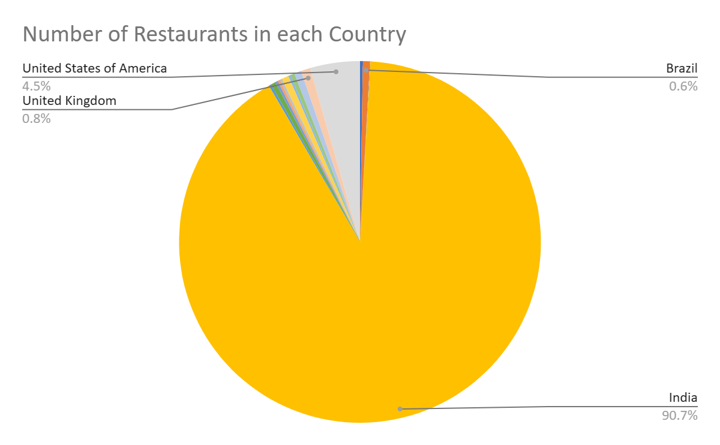

1. Come up with the names of States or cities in the suggested countries suitable for opening restaurants.

Name the chart/spreadsheet function you will use for solving the problem?

* Bar Chart is used for solving the above problem with the help of Lookup Function to get the desired cities with a smaller number of restaurants and also less ratings.

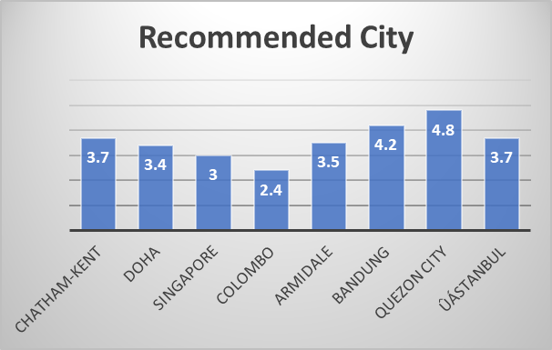

* Therefore, the recommended cities for new restaurants will be Chatham-Kent, Doha, Singapore, Colombo and Armidale because -
* Less number of restaurants in the city
* Rating less than Average rating

1. According to the countries you suggested, what is the current quality in terms of ratings for restaurants that are opened there?

Will you use any aggregation function or a visualization here to solve the problem?

* For the above task, it is preferred to have a visualization between the Average of Ratings vs. Countries to analyse the current quality of restaurants based on their ratings.

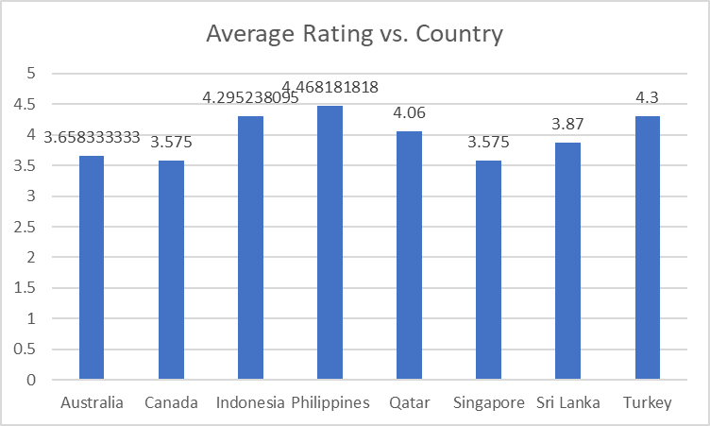

* It shows that out of the suggested countries Philippines has the highest average rating and Canada has the lowest.

1. Also what is the current expenditure on the food in the suggested countries, so that we can keep our financial expenditure in control?  
   Mention the functionality which you will use for giving the suggestions, will it be any aggregate function or a visualization?

* Column chart is used to analyze the average cost for two vs each country to find the expenditure of the suggested countries

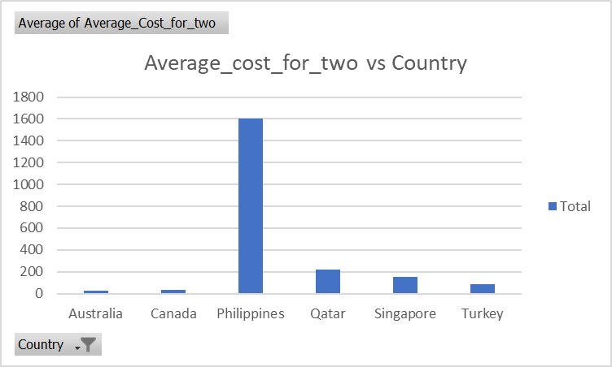

1. Come up with the names of restaurants from the recommended states or cities who are our biggest competitors and also those which are rated in the lower brackets, i.e. 1-2 or 2-3.

How do you decide if anyone is a competitor?

* The condition for a restaurant to be a competitor will be to have rating more than 3 (Rating > 3). The list of recommended restaurants is present in the excel sheet.

1. Which cuisines should we focus on in the newer restaurants to get better feedbacks? Does the choice of cuisines affect the restaurant ratings?

What is the basis for the suggestions? And mention how did you decide if the cuisines affect the ratings?

* According to the suggested countries, each country has its own favourite cuisine with the highest rating.
* Yes! The choice of cuisine affects the restaurant ratings because of the geographic location of the country and availability of food resources there.
* It can be seen from the data that coastal countries like Sri Lanka and Indonesia are more focussed on Seafood and Non-vegetarian foods, being the island countries whereas western countries like Canada and Australia prefer eating more of their native food items.

1. According to our current data, should we go for online delivery and table booking? Does that affect the customer’s ratings?

Mention your approach and spreadsheet function for the answer.

* According to the data, restaurants having both online delivery and table booking facility have better ratings than others. Therefore, we should go for online delivery and table booking.
* Pivot Table between has_online_delivery & has_table_booking was created with the average rating as the value.
* The restaurants having both online delivery and table booking have better ratings than restaurants having none of them.

1. Should the team keep the rate of cuisines higher? Will that affect the feedback? According to our data are the rate of cuisines and ratings, correlated?
2. What is the distribution of the number of restaurants of different price ranges in all the countries? Distribution means the numbers of different price ranges, how will you show this using a chart

* The distribution of the number of restaurants of different price ranges are shown in the below clustered column chart within the suggested countries.
* Clustered column chart is used to visualise such kinds of problems.

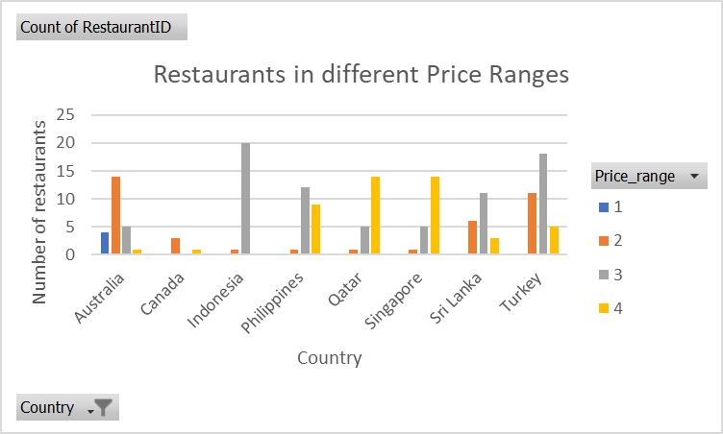

1. Explain your approach in brief for suggesting countries/cities in order to open new restaurants, if the objective and subjective questions would have not been given to assist you.

[you have to give bullet pointers in order to answer this question]

Back the suggestion with proper insights and visualisation.

* I would have focussed the analysis on the number of restaurants present in a country/city and the rating of those restaurants.
* The cities with less no. of highly rated restaurants would be my main suggestion for opening new restaurants.
* I would have also undertaken online delivery option and table booking facility analysis to judge the number of restaurants providing this facility.
* The price range would also be a crucial aspect of analysis.